In MATLAB, there is a handy function called reshape which can reshape an m x n matrix into a new one with a different size r x c keeping its original data.

You are given an m x n matrix mat and two integers r and c representing the row number and column number of the wanted reshaped matrix.

The reshaped matrix should be filled with all the elements of the original matrix in the same row-traversing order as they were.

If the reshape operation with given parameters is possible and legal, output the new reshaped matrix; Otherwise, output the original matrix.

**Example 1:**

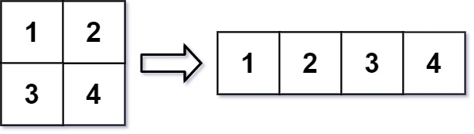

**Input:** mat = [[1,2],[3,4]], r = 1, c = 4

**Output:** [[1,2,3,4]]

**Example 2:**

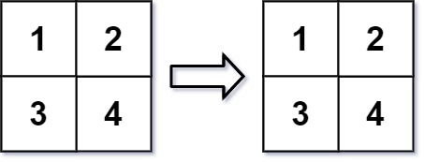

**Input:** mat = [[1,2],[3,4]], r = 2, c = 4

**Output:** [[1,2],[3,4]]

**Constraints:**

* m == mat.length
* n == mat[i].length
* 1 <= m, n <= 100
* -1000 <= mat[i][j] <= 1000
* 1 <= r, c <= 300